MAHATMA EDUCATION SOCIETY’S
PILLAI COLLEGE OF ARTS, COMMERCE & SCIENCE
(AUTONOMS) NEW PANVEL

PROJECT REPORT IDC BAF-MARKETING AND RETAIL MANAGEMENT
MARKETING AROUND US – UNDERSTANDING MARKETING & AMP; RETAIL THROUGH DAILY LIFE

IN PARTIAL FULFILLMENT
BACHELOR OF SCIENCE COMPUTER SCIENCE

SEMESTER II– 2025-26

PROJECT GUIDE
PROFESSOR. FIZA MIYAN

SUBMITTED BY
KRISHNA KAMLESH SINGH
ROLL NO. 1400

Introduction
Marketing is an integral part of our everyday life and influences our choices through products, stores, and promotional offers. The objective of this research report titled “Marketing Around Us – Understanding Marketing & Retail Through Daily Life” is to understand how marketing and retail concepts are applied in real-life situations by relating theory with daily consumer experiences.
This report is prepared as part of the Marketing and Retail Management course for Semester II and provides practical exposure to key marketing concepts such as marketing activities, pricing strategies, retail formats, and customer relationship management (CRM). Real-life examples such as Croma, Reliance Smart, and an Android smartphone have been selected for better understanding.
Section A studies marketing activities at Croma and evaluates whether the store follows a selling or marketing approach.
Section B analyzes the pricing strategy of an Android smartphone, focusing on price range and influencing factors.
Section C reflects on the retail experience at Reliance Smart, including its retail format and customer retention practices.
Section D involves designing a simple marketing poster for Croma, featuring the Motorola Edge 50 Neo, highlighting students as the target market and promotion as the key marketing mix element.
Overall, the report helps bridge the gap between theoretical knowledge and practical understanding of marketing and retail management in daily life.


Section A: Marketing in Daily Life

Visit to Croma – Palava City, Dombivli

Introduction
Marketing is not limited to advertisements on television or social media; it is present all around us in our daily life. Every shop, mall, and brand uses marketing strategies to attract customers, satisfy their needs, and build long-term relationships. To understand the concept of marketing in real life, I recently visited Croma, an electronics retail store located at Palava City, Dombivli. This visit helped me understand how marketing concepts are applied practically in a retail environment.

About the Company – Croma
Croma is one of India’s leading large-format retail chains for consumer electronics and appliances. It is a part of the Tata Group and is operated by Infiniti Retail Ltd. Croma was established in 2006 with the objective of providing customers with a wide range of electronic products under one roof along with expert guidance and reliable after-sales service.
Croma sells a variety of electronic and digital products such as:
- Mobile phones and accessories
- Laptops, tablets, and computers
- Televisions and home entertainment systems
- Home appliances like refrigerators, washing machines, air conditioners, and microwave ovens
- Kitchen appliances and personal care products
- Smart gadgets, wearables, and audio devices
The main focus of Croma is not only to sell products but also to help customers choose the right product according to their needs, budget, and usage.

Location of the Shop
The Croma store I visited is located at Palava City, Dombivli, which is a well-developed residential and commercial area. The store is situated in a prime location with good connectivity and high footfall. Being located near residential societies makes it convenient for families and working professionals to visit the store easily. The spacious layout, bright lighting, and organized product sections create a comfortable shopping experience for customers.
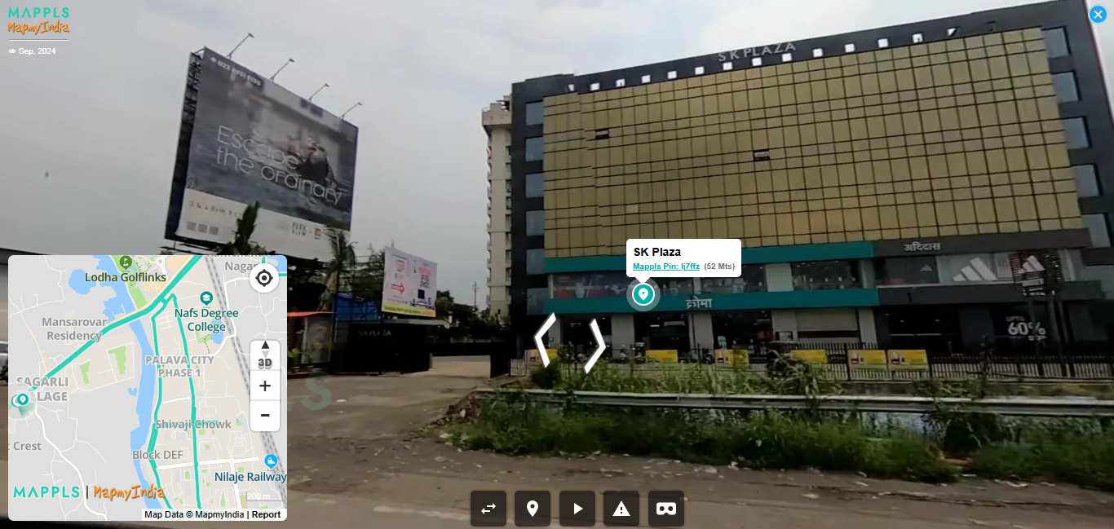

Marketing Activities Used by the Shop
During my visit, I observed several marketing activities used by Croma to attract and retain customers. Two important marketing activities are explained below:

1. Product Display and Store Layout
Croma uses effective visual merchandising as a marketing tool. Products are neatly displayed in separate sections such as mobiles, laptops, TVs, and home appliances. Demo units are available for many products, allowing customers to experience the product before purchasing. Clear signboards, price tags, and product information boards help customers compare different brands and models easily. This attractive display encourages customers to spend more time in the store and increases the chances of purchase.

2. Offers and Promotional Schemes
Another important marketing activity observed was the use of offers and discounts. Croma provides special festival offers, exchange offers, bank card discounts, and no-cost EMI options. These offers are clearly communicated through posters, standees, and digital screens inside the store. Such promotional activities create value for customers and motivate them to buy high-priced electronic items without financial burden.

Selling vs Marketing: What Does Croma Focus On?
Croma focuses more on marketing rather than just selling.
Selling is mainly concerned with persuading customers to buy a product, whereas marketing focuses on understanding customer needs, providing suitable products, and ensuring customer satisfaction.
At Croma, sales executives first interact with customers to understand their requirements, such as budget, usage, and preferences. They then suggest suitable options instead of forcing a particular product. The availability of product demos, detailed explanations, warranty information, and after-sales services like installation and support shows a customer-oriented approach.
Therefore, Croma follows the marketing concept, where the customer is at the center of all activities. The aim is to build trust and long-term relationships rather than making only one-time sales.

Conclusion
The visit to Croma at Palava City, Dombivli clearly shows how marketing plays an important role in daily life. Through attractive product displays, promotional offers, customer interaction, and service support, Croma successfully applies marketing principles in its retail operations. The store focuses more on marketing than selling, as it prioritizes customer needs and satisfaction. This practical example helped me understand the difference between marketing and selling in a real-world business environment.

SECTION B: Pricing Strategy Observation

Selected Product: Mobile Phone (Android Smartphone)

Introduction
Pricing is one of the most important elements of the marketing mix. The price of a product directly affects consumer buying decisions, company profits, and market positioning. In daily life, students frequently purchase mobile phones, making it a suitable product to observe and understand pricing strategies. For this section, I have selected an Android mobile phone, which is commonly used by students for online classes, communication, entertainment, and daily activities.

Price of the Product
As a student, the most preferred Android smartphones fall within a reasonable and affordable price range. Generally, a good Android mobile phone suitable for student usage is priced between ₹15,000 to ₹25,000. This price range offers a balance between performance, features, and affordability. In this range, students get good processors, sufficient storage, quality cameras, long battery life, and access to the latest applications.
Popular brands offering mobiles in this price range include Samsung, Redmi, Realme, Vivo, OnePlus (Nord series), and Motorola. These brands aim to attract price-sensitive yet feature-conscious customers.

Factor Influencing the Pricing of Mobile Phones
One major factor influencing the pricing of Android mobile phones is competition.
The smartphone market is highly competitive, with many brands offering similar features at comparable prices. To stay relevant and attract customers, companies closely observe competitor pricing before fixing the price of their products. If one brand reduces its price or offers better features at the same price, other brands are forced to adjust their pricing accordingly.
Apart from competition, factors like production cost, demand, technological advancement, and brand image also influence pricing. However, competition plays the most important role in deciding prices in the student-friendly mobile segment.

Pricing Strategy Used
The pricing strategy mainly used for Android smartphones in the ₹15,000 to ₹25,000 range is the Competitive Pricing Strategy.

Justification of the Pricing Strategy
Under the competitive pricing strategy, companies set prices based on what competitors are charging for similar products. In the Android smartphone market, brands offer similar specifications such as camera quality, RAM, storage, and battery life at nearly the same price. This helps companies attract customers without pricing the product too high or too low.
This strategy is suitable because students are price-sensitive and compare different brands before making a purchase. Competitive pricing ensures that the product remains affordable while still offering value for money. Therefore, Android mobile phone brands mainly use competitive pricing to survive and grow in a highly competitive market.

Conclusion
The pricing of Android mobile phones clearly reflects the application of pricing management concepts in real life. With a price range of ₹15,000 to ₹25,000, companies focus on affordability and value. Competition is the key factor influencing pricing, and the competitive pricing strategy is widely used. This strategy helps companies attract student customers and maintain a strong position in the market while fulfilling consumer expectations.

SECTION C: Retail Experience Reflection

Visit to Reliance Smart

Introduction
Retailing plays an important role in connecting producers with final consumers. Different retail formats such as supermarkets, malls, and specialty stores aim to provide convenience, variety, and value to customers. To understand retail concepts and customer relationship management (CRM) in real life, I am reflecting on my visit to Reliance Smart, a popular retail store known for daily grocery and household shopping.

Type of Retail Format
Reliance Smart follows the supermarket retail format. It is a self-service store where customers can directly select products from shelves and make payment at billing counters. The store mainly focuses on selling fast-moving consumer goods (FMCG) such as groceries, food items, personal care products, and household essentials. This format offers convenience, wide product variety, and affordable pricing, making it suitable for regular household purchases.

Facilities and Services Provided to Customers
Reliance Smart provides several facilities and services to enhance customer convenience. Two important services are explained below:

1. Organized Store Layout and Self-Service
The store has a well-organized layout with separate sections for groceries, fruits and vegetables, dairy products, snacks, and household items. Clear labeling and aisle signs help customers find products easily without assistance. The self-service system allows customers to shop at their own pace, saving time and improving the overall shopping experience.

2. Billing and Digital Payment Facilities
Reliance Smart provides fast billing counters along with multiple digital payment options such as UPI, debit cards, credit cards, and mobile wallets. This reduces waiting time and offers convenience to customers. Some stores also provide express counters for quick purchases, which further improves customer satisfaction.

Customer Retention Strategies Used by Reliance Smart
Reliance Smart uses various strategies to retain customers and build long-term relationships, which reflects the concept of Customer Relationship Management (CRM).
- Discounts and Offers: Regular discounts on essential items, combo offers, and festival schemes attract repeat customers.
- Reliance One / Membership Programs: Loyalty programs help customers earn points and receive exclusive offers, encouraging repeat visits.
- Quality and Consistency: Consistent product availability and reasonable pricing build trust among customers.
- Personalized Offers: Through digital records and apps, customers receive customized offers based on their purchase history.
These strategies help Reliance Smart maintain a loyal customer base.

Comparison Between Reliance Smart and Croma
Basis | Reliance Smart | Croma
Type of Store | Supermarket | Specialty Electronics Store
Products Sold | Groceries, FMCG, daily essentials | Electronics and appliances
Purchase Frequency | High (daily/weekly) | Low (occasional)
Customer Service | Limited assistance, self-service | High involvement and expert guidance
Pricing Approach | Low-price and discount-focused | Value-based and feature-focused
CRM Focus | Loyalty cards and regular offers | Personalized selling and after-sales service
Although both Reliance Smart and Croma are retail stores, they differ in their retail format, product range, and customer approach.
Reliance Smart focuses on convenience, affordability, and frequent purchases, while Croma focuses on expert advice, product demonstrations, and customer satisfaction for high-value products.

Conclusion
The retail experience at Reliance Smart highlights the importance of supermarket retail formats and CRM practices in daily life. By offering convenient services, attractive offers, and loyalty programs, Reliance Smart successfully retains customers. When compared with Croma, both stores follow different retail strategies based on their product category and customer needs. This reflection helps in understanding how retail formats and CRM concepts are applied practically in the retail industry.

SECTION D: Marketing Poster Creation

Selected Retail Store: Croma

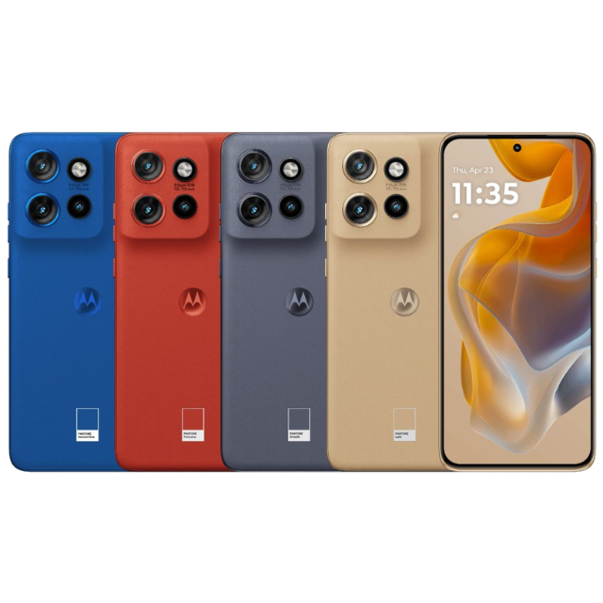
Marketing posters are an important promotional tool used by retail stores to attract customers and communicate product benefits effectively. In this section, a creative marketing poster is designed for the retail store Croma, focusing on a smartphone product suitable for student customers.
The product selected for the poster is the Motorola Edge 50 Neo, which is a modern Android smartphone offering good performance, attractive design, and useful features at an affordable price. This makes it an ideal choice for students who require a smartphone for online learning, communication, entertainment, and daily use.
The target customers for this poster are students. Students are price-sensitive and look for value-for-money products that provide reliability, performance, and long-term usability. The poster is designed keeping their needs and preferences in mind.
The key marketing message / slogan used in the poster is:
“Smart Performance. Stylish Design. Perfect for Student Life.”
This slogan clearly highlights the benefits of the product and connects it directly with student lifestyle and usage.
The promotion tool highlighted in the poster is a special student discount offer, along with options such as bank discounts or no-cost EMI. These promotional offers make the product more affordable and encourage students to purchase the smartphone from Croma.
The element of the marketing mix clearly highlighted in this poster is Promotion. The use of discounts, attractive slogans, and student-focused messaging helps in creating awareness and interest among customers.
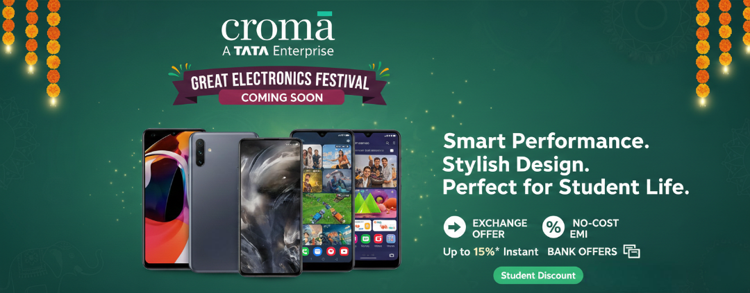


----- END OF REPORT -----

REPORT BY: 1400. KRISHNA KAMLESH SINGH (FY BSC CS- C 2025-26)
DATE: 20TH JANUARY 2026

